DEVELOPING ICT STRATEGY IN THE INDONESIAN MINING SECTOR
Affiliation
Joe Otway  Megaprime Pty Ltd  Email: jotway@megaprime.com.au | Tajuddin Ismail  Mitrais/Mincom Group  Email: tajuddin.ismail@mincom.co.id

Abstract
The Indonesian mining sector is responding to increased demand for minerals with comprehensive expansion programs that include information and communications (ICT) systems.
The paper describes the approach used and experience gained developing ICT strategy in the Indonesian mining sector.
Combining recommendations of best practice authorities we created an approach that delivers an ICT strategy consisting of implementation plans for business systems, support systems, hardware, networks and ICT management processes.
Using questionnaires and interviews to gather information from senior business and ICT managers, and follow-up workshops to confirm strategic business requirements for ICT and the capability levels of ICT management processes, we designed a program of ICT projects that support the companies’ business strategy.
A key objective of this ICT strategy is to ensure that the necessary processes are in place to align the business and ICT strategy and enable quality ICT service delivery and support. Using the 34 COBIT ICT processes, their critical success factors and capability maturity models, we established the capability maturity levels of each company’s ICT processes. Based on our findings, we then developed a prioritised program of process improvement projects that provide the foundation for the implementation of strategically aligned business systems and technical infrastructure.

Keywords
Indonesia mining information ICT strategy governance management COBIT requirements capability maturity process improvement system strategic alignment

THE CONTEXT
Like the Australian mining sector, in 2005 the Indonesian mining sector is characterised by:
- Unprecedented demand for products
- Sudden appearance of new markets
- Demand greater than production capability
- Demand greater than logistical capability
- National growth straining national infrastructure
- Skills shortage impeding national growth
- Layers of government are difficult to navigate
- New national standards and legal constraints
- Increasing cost of labour
Indonesian mining companies are responding to increased demand for minerals with comprehensive expansion programs that include information and communications (ICT) systems. We have worked with some of the Mitrais/Mincom Group’s clients to develop ICT strategy that supports their expansion programs. These companies:
- Have been established ten years or more
- Are listed on the Jakarta Stock exchange or are the subsidiaries of multinationals
- Have multiple, widely distributed mineral deposits and port facilities
- Are increasing the capacity of their exploration, mining, mineral processing, supporting infrastructure and port facilities
- Are actively seeking new business opportunities
- Are not new to ICT
The ICT systems that they currently run include supply chain management, maintenance management, mine planning, financial accounting, process control, SCADA, hospital management, and office automation tools such as Microsoft Office. Many of these systems have been in place for some years and now need to be replaced, upgraded or overhauled for the following reasons:
- Insufficient network capacity
- Questionable information quality
- Full functionality of system not used
- User requirements not being addressed
- ICT governance needs improvement
- ICT management needs improvement
The companies had no processes for ICT strategic planning or defining enterprise architecture. ICT was a low priority for their internal auditors.

OUR APPROACH
To support their expansion plans the companies needed to:
- Improve ICT governance
- Improve ICT management
- Implement business-aligned application systems
- Implement appropriate business application support systems, hardware, networks, and ICT processes
- Improve ICT service delivery & support
Clearly this would require a lot of effort and resources.
We needed a strategy that was structured, all-encompassing and forward looking. There are many definitions of strategy but one that we liked says that strategy is “a sequence of interrelated decisions, resource allocations and actions designed to accomplish an objective within a specified period of time.” We also needed a process to develop, implement and manage the strategy. Our process approach to ICT strategic management is illustrated in Figure 1.
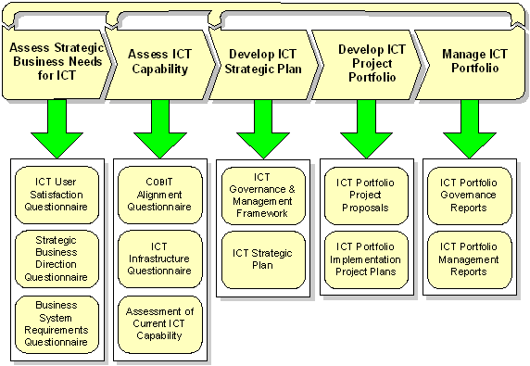
Figure 1 Our ICT strategic management process.
We decided to base our strategy on the recommendations of best practice authorities including the IT Governance Institute, Gartner and others such as Benson, Bugnitz & Walton. We also identified and consulted with stakeholders including company directors, business system users, business managers, ICT personnel, customers, suppliers and both external & internal auditors. We reviewed internal documentation including audit reports, life-of-mine plans, business plans and SWOT analysis. We also developed questionnaires to gather structured information about:
- Strategic requirements for business application systems
- User satisfaction with ICT services
- Operational business application systems
- ICT infrastructure including support systems, hardware and networks
- Alignment with the COBIT Framework
We produced a collection of documentation items making extensive use of Microsoft’s Access database as a means of capturing, organizing and reporting information. The key documentation items are:
- ICT governance & management framework
- Confirmation of strategic systems requirements
- Assessments of ICT user satisfaction, business systems, ICT Infrastructure and COBIT alignment
- ICT SWOT Analysis
- ICT Strategy including proposed implementation plans for business systems, support systems, hardware, networks, and ICT processes
The documentation items that we produced are identified in Figure 2.
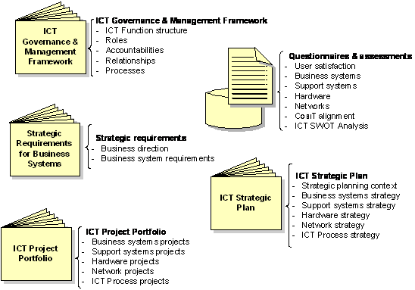
Figure 2 Documentation items produced.

TWO LONG-STANDING CHALLENGES TO ICT
Those seeking to optimise the value contribution of ICT face two long-standing challenges. The first is to ensure what is often called ICT strategic alignment. Strategic alignment is the state that exists when business strategy, ICT strategy, organizational infrastructure and processes and ICT infrastructure and processes are aligned. The IT Governance Institute considers strategic alignment to be one of the objectives of ICT Governance.
ICT governance is about power. It is the responsibility of the board of directors and executive management and is an integral part of enterprise governance. ICT governance consists of the leadership, organizational structures and processes that ensure that the organization’s ICT sustains and extends the organization’s strategies and objectives. The objectives IT governance are defined by the IT Governance Institute to be:
- Strategic alignment
- ICT risk management
- Optimal resource usage
- Value delivery
- Performance measurement
A prerequisite to gaining the objectives of ICT governance is to implement appropriate ICT processes and manage them well. Knowing what these processes are and knowing how to manage them is the second long-standing challenge to ICT. The COBIT ICT process management framework provides the means to identify these processes and to manage them effectively and efficiently.
The following sections provide an overview of the ICT governance & management framework that we recommend and the use we made of COBIT as a guideline for ICT processes management.

ICT Governance & MANAGEMENT FRAMEWORK
Most companies did not have an appropriate framework for ICT governance and management. We introduced a framework for ICT governance and management with the structure that is illustrated in Figure 3.
The ICT Strategy committee has a strategic focus. It reports to and represents the board of directors and is responsible for the ICT Governance process.

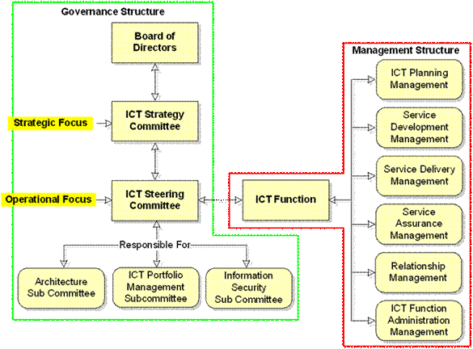
Figure 3 The ICT governance & management framework
The ICT Steering Committee has an operational focus. It reports to the ICT Strategy Committee and oversees the ICT Function, convening sub-committees as necessary to deal with important matters whose implications extend beyond the boundaries of the ICT Function.
The ICT Function is accountable for the effective and efficient management of ICT processes which we grouped into six ICT service management functions. We mapped each of the 34 COBIT processes into the six ICT service management functions on a one-to-one basis.

COBIT PROCESSES & the COBIT MANAGEMENT GUIDELINES
COBIT (Control Objectives for Information and Related Technology) has been developed as a generally applicable and accepted standard for good Information Technology (IT) security and control practices that provides a reference framework for management, users, and IS audit, control and security practitioners. COBIT consists of 34 processes organized into 4 domains as illustrated in Figure 4.

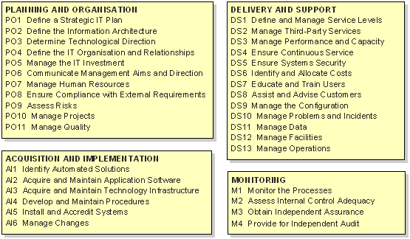
Figure 4 The COBIT domains and processes.
We like COBIT because:
- It is an evolving consensus view of what ICT processes are
- It has a good pedigree
- It is recognized internationally
- We believe it provides the most complete mapping to COSO
- It represents best/good ICT and process management practice
- It is comprehensive & complete
- It provides a sound foundation for implementing AS17799, AS7799, AS8018, AS2834
- It is product independent
We used the Maturity Models, Critical Success Factors (CSFs), Key Goal Indicators (KGIs) and Key Performance Indicators (KPIs) provided by the COBIT Management Guidelines to assess and measure each organization’s ICT environment against the COBIT framework’s 34 ICT processes. These metrics are explained briefly in Table 1.
Table 1 The components of the COBIT Management Guidelines
Component | Description
CMM | Capability Maturity Model. A standard, typically consisting of four or five layers of graduation, used to measure an organization’s ability to perform a process.
CSF | Critical Success Factors are the strategic, technical and organizational prerequisites for successful implementation.
KGI | Key Goal Indicators identify and measure service outcomes in terms that tell management whether a service has achieved its business objectives. They measure the effectiveness and efficiency of the service’s products.
KPI | Key Performance Indicators are lead indicators that measure how well a service’s internal processes are performing. KPIs are often used to measure CSFs and can be used to identify service improvement opportunities.

The purpose of establishing each ICT Function’s degree of alignment with COBIT was to determine requirements for an ICT process improvement strategy that would:
1 Identify target Capability Maturity Levels (CMLs) for the 34 COBIT processes and process CSFs
2. Position selected processes at level 3 or 4 as required
Table 2 and Table 3 show the capability maturity levels that we assessed for two of the COBIT processes.

Table 2 M1 MONITOR THE PROCESSES
# | Critical Success Factor | CML
1 | Useful, accurate and timely management reports are available. | 0
2 | Processes have defined and understood Key Goal Indicators and Key Performance Indicators | 0
3 | Measurements of IT performance include financial, operational, customer and organizational learning criteria that ensure alignment with organization-wide goals and can be integrated with tools such as the IT Balanced Business Scorecard | 0
4 | There are clearly understood and communicated process objectives | 1
5 | A framework is established for defining and implementing IT governance reporting requirements | 0
6 | A knowledge base of historical performance is established | 0
Table 3 DS3 MANAGE PERFORMANCE & CAPACITY
# | Critical Success Factor | CML
1 | The performance and capacity implications of IT service requirements for all critical business processes are clearly understood | 1
2 | Performance requirements are included in all IT development and maintenance projects | 1
3 | Capacity and performance issues are dealt with at all appropriate stages in the system acquisition and deployment methodology | 2
4 | The technology infrastructure is regularly reviewed to take advantage of cost/performance ratios and enable the acquisition of resources providing maximum performance capability at the lowest price | 1
5 | Skills and tools are available to analyze current and forecasted capacity | 1
6 | Current and projected capacity and usage information is made available to users and IT management in an understandable and usable form | 1
Subsequent discussion with the managers of the ICT service management functions accountable for each process and other stakeholders in which target CML’s were agreed resulted in ICT process improvement projects being defined, incorporated in the ICT Strategic plan and submitted to the ICT Strategy Committee for approval as components of the ICT strategy.

CONCLUSION:
Two long-standing challenges for ICT are to establish and maintain the alignment between business strategy and ICT strategy and know what processes should be implemented to ensure that ICT is managed efficiently and effectively.
Our suggestion to organizations that struggle with these issues is to implement a strategic management process such as that illustrated in Figure 1. The process consists of the following five steps:
- Assess strategic business needs for ICT and translate these into requirements for business application systems
- Assess the capability of the ICT Function to deliver and support the systems needed to satisfy business application system requirements
- Develop a strategic plan that satisfies business application system requirements consisting of a program of implementation projects for business applications, supporting applications, hardware, networks and ICT processes
- Apply the processes and procedures of the ICT governance and management framework to review and approve the projects before undertaking them
- Apply the principles of ICT portfolio management to projects and status quo systems
The process enables business strategy to drive ICT strategy and in doing so assures that ICT expenditure is both dedicated to supporting business activity and optimized to this end using the methods of ICT portfolio management. The process transforms the “as-is” enterprise architecture into its “to-be” form and should be integrated with the organization’s annual planning and budgeting processes.

Shendal. Managing Industry and Organizational Structure in McLimore Fred J., Laurie Larwood Strategies… Successes… Senior Executives Speak Out, Strategies. New York: Harper & Row Publishers, 1987 ISBN 0060443545.
IT Governance Institute. Boardroom Briefing on IT Governance 2nd Edition ISBN 189320964-4, 2003. (www.itgi.org).
Benson, Robert J., Thomas L. Bugnitz & William B Walton. From Business Strategy to IT Action. New Jersey John Wiley & Sons ISBN 0471491918. 2004.
Henderson, J C Venkatraman, N. Strategic Alignment: Leveraging information technology for transforming organizations. IBM Systems Journal VOL 38 NOS 2&3. 1999.
CobiT, is issued by the Information Systems Audit and Control Association’s (ISACA) IT Governance Institute and is downloadable from the Information System audit and Control website (www.isaca.org).
Information Systems Audit and Control Association (ISACA). 2000 Control Objectives for Information and Related Technology (CobiT) – Management Guidelines, 3rd edition. (rolling Meadow, IL,)

